1. A door sensor is connected to bit 1 of port B and LED is connected to bit 7 of port C. Monitor the door sensor, and when it opens, turn the light
Program
#include <avr/io.h> // standard AVR header
int main(void)
{
DDRB = DDRB & 0b11111101; // pin 1 of Port B is input
DDRC = DDRC | 0b10000000; // pin 7 of Port C is output
while (1)
{
if (PINB & 0b00000010) // check pin 1 (2nd pin) of PINB
PORTC = PORTC | 0b10000000; // set pin 7 (8th pin) of PORTC
else
PORTC = PORTC & 0b01111111; // clear pin 7 (8th pin) of PORTC
}
return 0;
}
Circuit Configuration
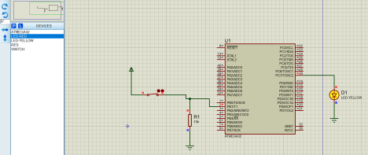
2. 7-Segment Display
Program
#define F_CPU 16000000UL
#include <avr/io.h>
#include <util/delay.h>
unsigned char seg_code[10] = {
0x3F, // 0
0x06, // 1
0x5B, // 2
0x4F, // 3
0x66, // 4
0x6D, // 5
0x7D, // 6
0x07, // 7
0x7F, // 8
0x6F // 9
};
int main(void)
{
DDRB = 0xFF; // PORTB as output
while(1)
{
for(int i = 0; i < 10; i++)
{
PORTB = seg_code[i];
_delay_ms(100);
}
}
}
Circuit Configuration
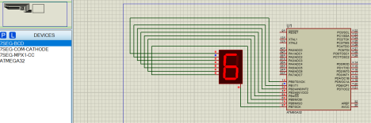3. Temperature Sensors
Use the folder
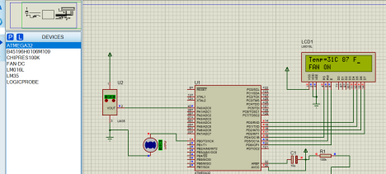4. LCD with ABCD display
Program
#define F_CPU 16000000UL
#include <avr/io.h>
#include <util/delay.h>
/* LCD Control Pins */
#define LCD_CTRL PORTC
#define LCD_CTRL_DDR DDRC
#define RS PC0
#define RW PC1
#define EN PC2
/* LCD Data Port */
#define LCD_DATA PORTB
#define LCD_DATA_DDR DDRB
void lcd_cmd(unsigned char cmd)
{
LCD_DATA = cmd;
LCD_CTRL &= ~(1 << RS); // RS = 0
LCD_CTRL &= ~(1 << RW); // RW = 0
LCD_CTRL |= (1 << EN);
_delay_ms(2);
LCD_CTRL &= ~(1 << EN);
}
void lcd_data(unsigned char data)
{
LCD_DATA = data;
LCD_CTRL |= (1 << RS); // RS = 1
LCD_CTRL &= ~(1 << RW); // RW = 0
LCD_CTRL |= (1 << EN);
_delay_ms(2);
LCD_CTRL &= ~(1 << EN);
}
void lcd_init()
{
LCD_DATA_DDR = 0xFF;
LCD_CTRL_DDR |= (1<<RS)|(1<<RW)|(1<<EN);
_delay_ms(20);
lcd_cmd(0x38); // 8-bit, 2 line
lcd_cmd(0x0C); // Display ON
lcd_cmd(0x06); // Auto increment
lcd_cmd(0x01); // Clear display
_delay_ms(2);
}
int main(void)
{
lcd_init();
lcd_data('A');
_delay_ms(100);
lcd_data('B');
_delay_ms(100);
lcd_data('C');
_delay_ms(100);
lcd_data('D');
_delay_ms(100);
while (1);
}
Circuit Diagram
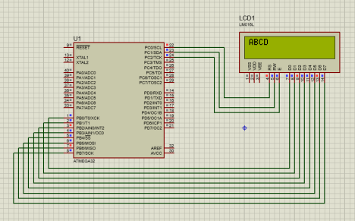5. Your Name on LCD
Program
#define F_CPU 16000000UL
#include <avr/io.h>
#include <util/delay.h>
/* LCD Control Pins */
#define LCD_CTRL PORTC
#define LCD_CTRL_DDR DDRC
#define RS PC0
#define RW PC1
#define EN PC2
/* LCD Data Port */
#define LCD_DATA PORTB
#define LCD_DATA_DDR DDRB
void lcd_cmd(unsigned char cmd)
{
LCD_DATA = cmd;
LCD_CTRL &= ~(1 << RS); // RS = 0
LCD_CTRL &= ~(1 << RW); // RW = 0
LCD_CTRL |= (1 << EN);
_delay_ms(2);
LCD_CTRL &= ~(1 << EN);
}
void lcd_data(unsigned char data)
{
LCD_DATA = data;
LCD_CTRL |= (1 << RS); // RS = 1
LCD_CTRL &= ~(1 << RW); // RW = 0
LCD_CTRL |= (1 << EN);
_delay_ms(2);
LCD_CTRL &= ~(1 << EN);
}
void lcd_string(char *str)
{
while (*str)
{
lcd_data(*str);
str++;
}
}
void lcd_init()
{
LCD_DATA_DDR = 0xFF;
LCD_CTRL_DDR |= (1<<RS)|(1<<RW)|(1<<EN);
_delay_ms(20);
lcd_cmd(0x38); // 8-bit, 2 line, 5x7
lcd_cmd(0x0C); // Display ON, cursor OFF lcd_cmd(0x06); // Increment cursor
lcd_cmd(0x01); // Clear display
_delay_ms(2);
}
int main(void)
{
lcd_init();
lcd_cmd(0x80); // First line
lcd_string("SIMANTA");
lcd_cmd(0xC0); // Second line
lcd_string("KASAJU");
while (1);
}
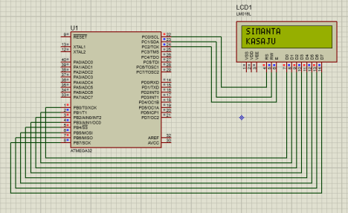6. Counter
Program
#define F_CPU 16000000UL
#include <avr/io.h>
#include <util/delay.h>
#include <stdlib.h> // for itoa
/* LCD Control Pins */
#define LCD_CTRL PORTC
#define LCD_CTRL_DDR DDRC
#define RS PC0
#define RW PC1
#define EN PC2
/* LCD Data Pins */
#define LCD_DATA PORTB
#define LCD_DATA_DDR DDRB
/* LCD Functions */
void lcd_cmd(unsigned char cmd)
{
LCD_DATA = cmd;
LCD_CTRL &= ~(1 << RS);
LCD_CTRL &= ~(1 << RW);
LCD_CTRL |= (1 << EN);
_delay_ms(2);
LCD_CTRL &= ~(1 << EN);
}
void lcd_data(unsigned char data)
{
LCD_DATA = data;
LCD_CTRL |= (1 << RS);
LCD_CTRL &= ~(1 << RW);
LCD_CTRL |= (1 << EN);
_delay_ms(2);
LCD_CTRL &= ~(1 << EN);
}
void lcd_string(char *str)
{
while (*str)
lcd_data(*str++);
}
void lcd_init()
{
LCD_DATA_DDR = 0xFF;
LCD_CTRL_DDR |= (1 << RS) | (1 << RW) | (1 << EN);
_delay_ms(20);
lcd_cmd(0x38); // 8-bit, 2 line
lcd_cmd(0x0C); // Display ON
lcd_cmd(0x06); // Auto increment
lcd_cmd(0x01); // Clear LCD
}
/* Timer1 1-second delay */
void timer1_delay_1s()
{
TCNT1 = 49911; // preload for 1 second TCCR1A = 0x00;
TCCR1B = (1 << CS12) | (1 << CS10); // Prescaler 1024
while (!(TIFR & (1 << TOV1))); // Wait for overflow
TIFR |= (1 << TOV1); // Clear overflow flag
}
int main(void)
{
char buffer[6];
int count = 0;
lcd_init();
lcd_cmd(0x80);
lcd_string("Counter:");
while (1)
{
lcd_cmd(0xC0); // Second line
itoa(count, buffer, 10); // int to string
lcd_string(buffer);
count++;
timer1_delay_1s();
lcd_cmd(0x01); // Clear LCD
lcd_cmd(0x80);
lcd_string("Counter:");

}
} Circuit
